**T*he Critical Path Method***

**It is the foundation in project planning.**

**Every project, regardless of its size or budget, has some core tasks that are crucial to its completion.**

**Critical Path: It is basically the path that is the bottleneck of the project. Reducing the overall implementation time frame will only be possible if activities on this path can be shortened, once the time required to implement non-critical activities does not affect the overall project duration. So usually speeding up all project activities in order to reduce the overall time frame is not necessary. Reducing the duration of one or more critical activities can reduce the overall project time frame; But it may also change the critical path so that activities that were previously not critical become so.**

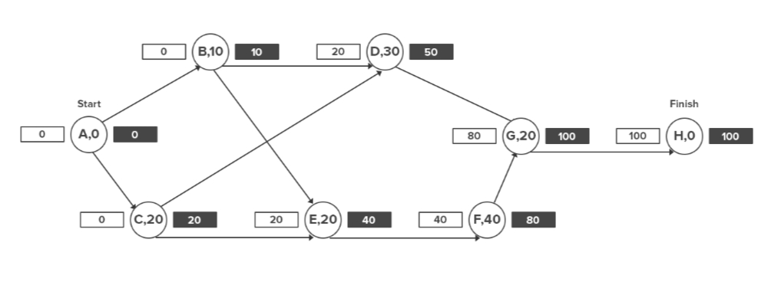

***The Critical Path Algorithm Explained:***

**The Critical Path Method is essentially an algorithm for decision making. This algorithm takes a task's start time, its duration, and finish time to figure out which activities deserve the most attention (i.e. are "critical" for the project).**

**Let's consider an example to understand the critical path algorithm better:**

|  |  |  |  |
| --- | --- | --- | --- |
| **Task Description** | **Task Predecessors** | **Task Description** | **Task ID** |
| **0** |  | **Project start** | **A** |
| **10** | **A** | **Buy Materials for A** | **B** |
| **20** | **A** | **Buy Materials for B** | **C** |
| **30** | **B,C** | **Build A** | **D** |
| **20** | **B,C** | **Build B** | **E** |
| **40** | **E** | **Polish and finish B** | **F** |
| **20** | **D,F** | **Join A and B** | **G** |
| **0** | **G** | **Project finish** | **H** |

**Since the project manager's goal is to complete the project as quickly as possible (without compromising on quality, of course), we'll try to find the earliest finish time for each activity.**

**To do this, organize all tasks into a flowchart and note their durations next to the task ID. The arrows indicate the sequence of activities. We'll mark the Earliest Start (ES) time to the left of the activity, and the Earliest Finish (EF) time to the right:**

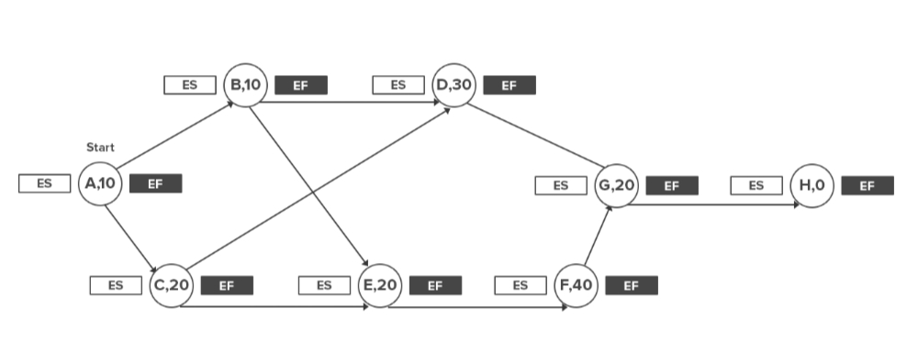**Mark the Start Time (S) to the left and right of the first activity. Usually, this would be 0.**

**Now mark the Earliest Start (ES) time of each activity. This is given by the largest number to the right of the activity's immediate predecessor (i.e. its Earliest Finish time, or EF).**

**If the activity has two predecessors, the one with the later EF time would give you the ES of the activity.**

**The EF of an activity is given by its Earliest Start time (ES) and its duration (t), i.e. ES + t.**

**Thus, if an activity's ES is 20 and will last for 10 days, its EF will be 30.**

**Mark all these figures in the flowchart.**

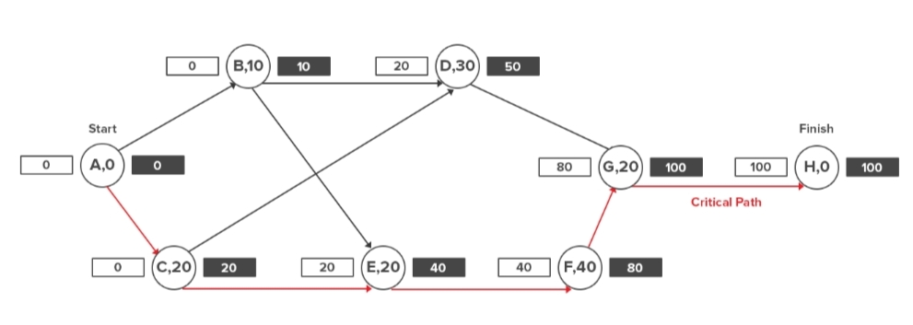

**The longest path will be the “critical path".**

**The final figure to the right of the last task in the sequence will give you the minimum time the project will take to finish .**

***A Step-by-Step Process for Using Critical Path Method:***

**This WBS is the first ingredient in using the Critical Path Method. If you don’t understand the role of the WBS or how to create one, I encourage you to read our beginner-friendly article first.**

**Once you have a WBS, jump straight to the first step.**

***Step 1: Identify activities based on WBS:***

**If you know your WBS, you would know that it describes deliverables, not activities. This is why all its components are described using nouns or adjectives, not verbs.**

**The CPM, however, focuses on activities described using verbs.**

**The first step the CPM process, therefore, is to list all the activities required to create deliverables at each level of the WBS.**

***Step 2: Identify all dependencies:***

**Any project has two types of tasks:**

**1- Tasks that depend on other tasks for their completion, i.e. dependent tasks.**

**2- Tasks that are independent of others and can be done in parallel to others, i.e. concurrent tasks.**

***Step 3: Create a network diagram:***

**Once you’ve identified all tasks and their dependencies, it’s time to create a network diagram, also known as a critical path analysis chart .**

**This chart visualizes separate activity sequences and enables you to map dependencies easily. To create it, make a list of all activity sequences. Create separate boxes for each task in the sequence .**

**Next, use arrows to identify dependencies between tasks in each sequence, like this:**

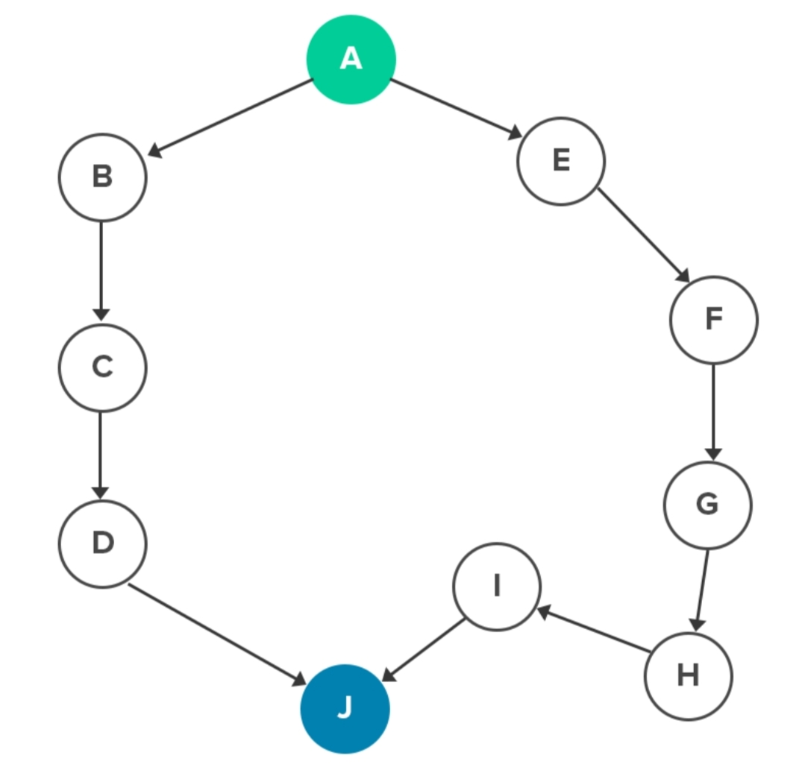

**This network diagram will form the basis of the final critical path.**

***Step 4: Estimate duration of each activity:***

**Recall that the critical path method describes the longest sequence of activities necessary to deliver the project successfully**

**Thus, to figure out the critical path, we first need to estimate the duration of each activity. The activity sequence that takes the longest time would then be our critical path.**

**There are several tactics you can adopt to estimate the duration of an activit .**

**Guesswork based on experience and knowledge . -1**

**2- Estimate based on past project .**

**Estimate based on industry benchmarks.-3**

**4- Estimates based on extrapolated data.**

**For example, if you know that it takes you 10 minutes to paint a 2’ x 2’ board (4 sq ft), you can estimate that it will take you 250 minutes to paint a 10’ x 10’ wall (100 sq ft).**

**However, even the best estimates can be inaccurate. Some tasks might be delayed because of unproductivity, delayed dependent tasks, or errors. Others might be completed earlier than expected because of an efficient worker.**

**To account for such contingencies, it is common to use three estimates for each activity:**

**Best-case scenario, i.e. shortest duration (A). -1**

**Normal scenario, i.e. expected duration (B). -2**

**3- Worst-case scenario, i.e. longest duration (C).**

**The average of these three cases would give you a reasonable estimate of each activity’s duration.**

**Activity Duration = A + B + C / 3.**

**If you’re dealing with activities you’ve performed several times in the past, you’ll likely have a better idea of its duration. In such a case, you can use a weighted average, giving additional preference to the “normal” scenario (B) according to your own confidence.**

**Weighted Activity Duration = A + 2B + C/3**

**List the duration (t) of each activity next to its name in the network diagram.**

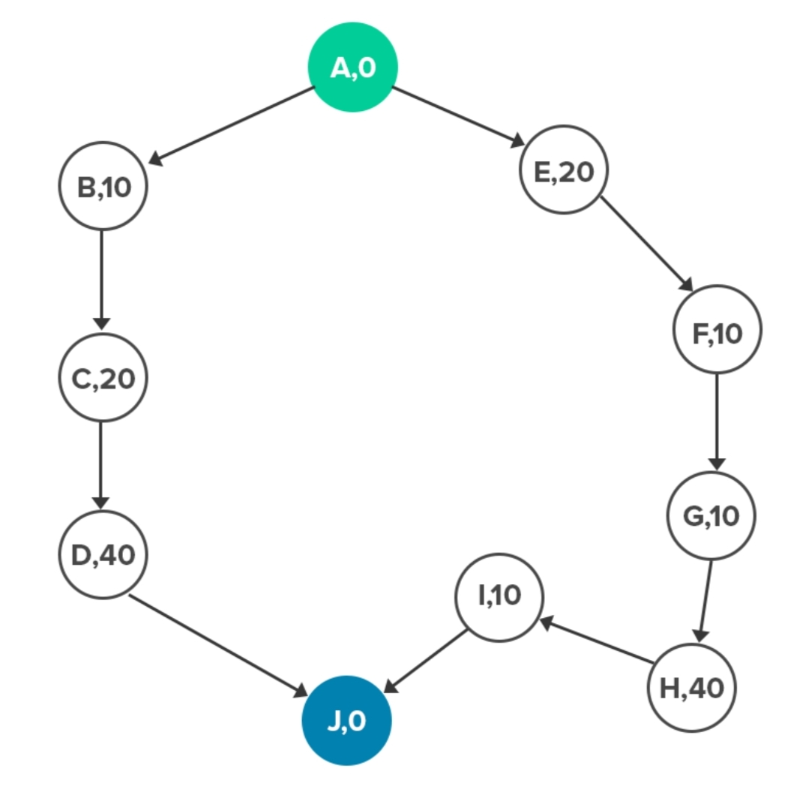

***Step 5: Calculate the Critical Path:***

**In your network diagram, write down the start and end time of each activity next to its box.**

**The first activity in the sequence would have a start time of ‘0’. Its end-time would be its duration.**

**The second activity’s start time would be the end-time of the first activity. Its end-time would be the start time + the duration.**

**Do this for all the activities in every sequence, like this:**

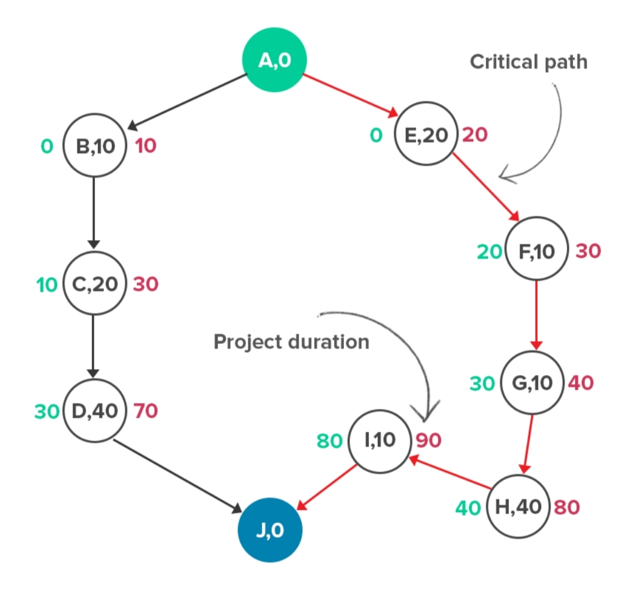

**Now, look at the last activity in each sequence. The figure to its right would tell you the duration of the entire sequence.**

**The activity sequence with the longest duration would be your critical path.**

**1- ريهام صلاح محمد محمود (سيكشن6)**

**2- ريهام مصطفي احمد محمد (سيكشن6)**

**3- ريهام حسن احمد عبد الهادي (سيكشن6)**

**4- ساره علي منسي عيد (سيكشن7)**

**5- سهيله علي محمد علي(سيكشن7)**

**6- رانيا مصطفي عبد الجواد على (سيكشن ٧)**